Adding a new circle:

There are two files you need to change:

1. index.html
2. stylesheet.css

Index.html

Example code for new circle:

<div id="julianknxxcl" class="inner-circle" onclick="openInNewTab('https://www.youtube.com/watch?v=GbhQmRIm4PU');">

<div class="turquoise-layer"></div>

<div class="info">

JulianKnxx - Candid Lover <br>

Songwriting/ Production/ Mixing

</div>

</div>

Code with places you need to change

<div id="CHANGEME1" class="inner-circle" onclick="openInNewTab('CHANGEME2');">

<div class="CHANGEME3”>

</div>

<div class="info">

CHANGEME4 <br>

CHANGEME5</div>

</div>

What to change them to:

1. Unique id for the song. Can be anything you like but would be good if it linked to the song. You will need to use this in the stylesheet.css document. Must be all one word with no spaces
2. Link to the spotify or youtube address you want to link it to. Make sure it is surrounded by speech marks
3. Either turquoise-layer or pink-layer
4. Name of the song
5. Role on the song

I have marked on the file where you need to paste this.

Stylesheet.css

Code to paste:

#julianknxxcl {

background-image: url("https://s3.eu-west-2.amazonaws.com/www.happycatjay.com/JulianKnxx+-+Candid+Lover.png");

}

Code with places you need to change:

#CHANGEME6 {

background-image: url("CHANGEME7");

}

1. Use the unique ID which you made up at stage 1. Make sure it is exactly the same including capitals. It must always have a hashtag before it.
2. URL of the photo from AWS

Uploading file to AWS

Go here <https://aws.amazon.com/>

Login

Click on S3

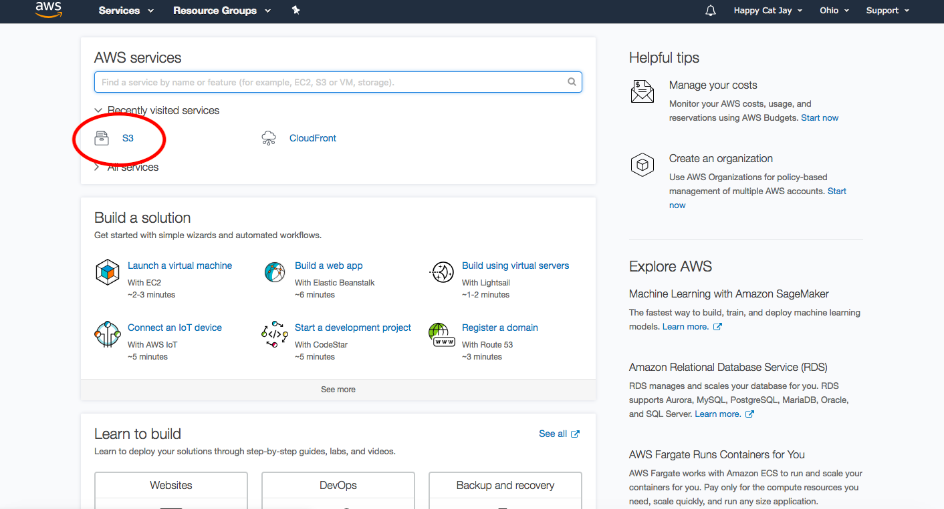

Click on [www.happycatjay.com](http://www.happycatjay.com)

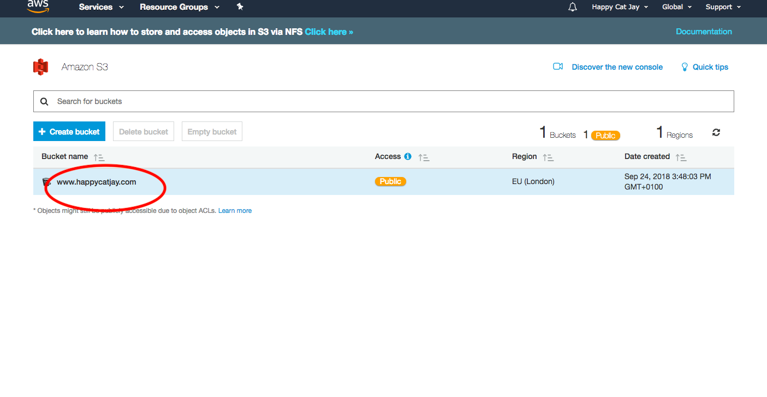

Click upload - menu will appear

Either drag and drop or upload – you’ll need to press next a couple of times – you don’t need to change anything

Click on the name of the photo you want to get the link to

Copy the link and paste into CSS

